**1.Write a program to design semantic and non - semantic tags with web page form layout to get this desired output.?**

**NAME: SREESANTHOSH PANDIAN**

**REGISTER NUMBER:0224F1271**

**HTML CODE**:

<!DOCTYPE html>

<head>

<title>My Website</title>

</head>

<body>

<h1>Welcome to my website!</h1>

<p>This is the home page of my website.</p>

<h2>About Me</h2>

<p>My name is John Doe and I'm a web developer.</p>

<ol>

<li>HTML5</li>

<li>CSS3</li>

<li>JavaScript</li>

</ol>

<p>Row 1, Column 1 Row 1, Column 2 <br>

Row 2, Column 1 Row 2, Column 2</p>

<h2>Contact Me</h2>

<form class="contact-form">

<table>

<tr>

<td><label for="name">Name</label></td>

<td>:</td>

<td><input type="text" id="name" name="name" required></td>

</tr>

<tr>

<td><label for="email">Email</label></td>

<td>:</td>

<td><input type="email" id="email" name="email" required></td>

</tr>

<tr>

<td><label for="message">Message</label></td>

<td>:</td>

<td><textarea id="message" name="message"></textarea></td>

</tr>

</table>

<button type="submit">Send</button>

</form>

<br>

<p>Write some content here<br>

Write some more content here</p>

</body>

</html>

**OUTPUT:**

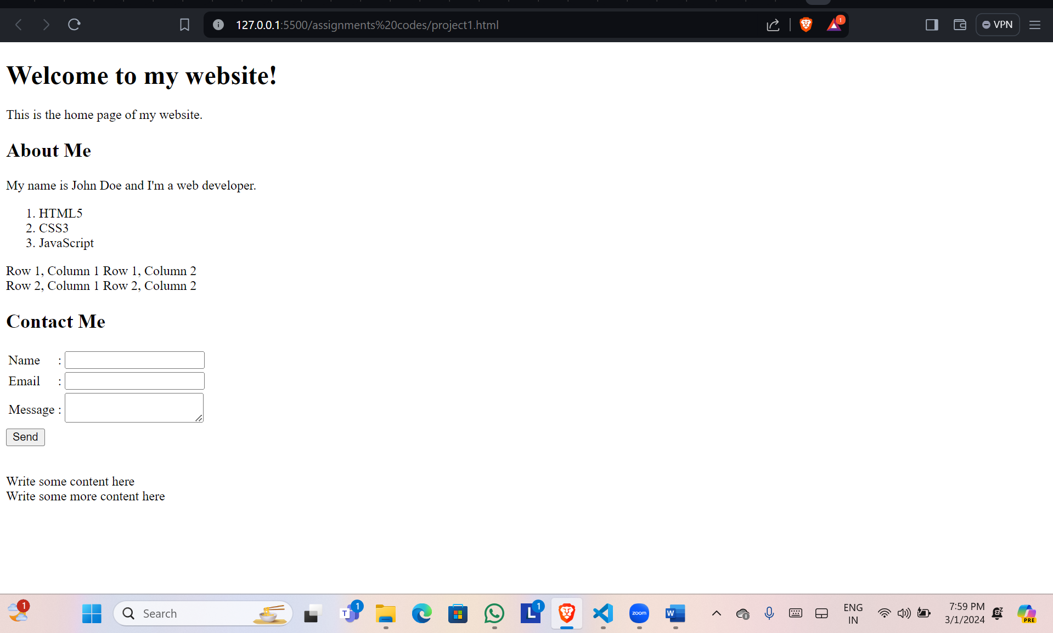

**2.Write a program to display the text formatting tags and meta tags in HTML as given below?**

**HTML CODE**:

<!DOCTYPE html>

<head>

<title>Text Formatting Example</title>

</head>

<body>

<h1>Text Formatting Example</h1>

<p>This is <strong>important</strong> text.</p>

<p>This is <em>emphasized</em> text.</p>

<p>This is <u>underlined</u> text.</p>

<p>This is <s>strikethrough</s> text.</p>

<p>This is <sup>superscript</sup> and this is <sub>subscript</sub> text.</p>

<p>This is <code>code</code> text.</p>

<p>These tags will be used to make <b>bold</b>, <i>italic</i>, and <u>underline</u> styles.</p>

<pre> This is preformatted text.

preserves white space and line breaks.</pre>

<blockquote><p>This is a block quote.</p>

<p> It can be used to indicate a long quotation that is set off from the main text.</p></blockquote>

<p>Superscript text appears half a character above the normal line, and is sometimes rendered in a smaller<br> font

<sub>superscript text can be used for footnotes like www.</sub> </p>

</body>

</html>

**OUTPUT:**

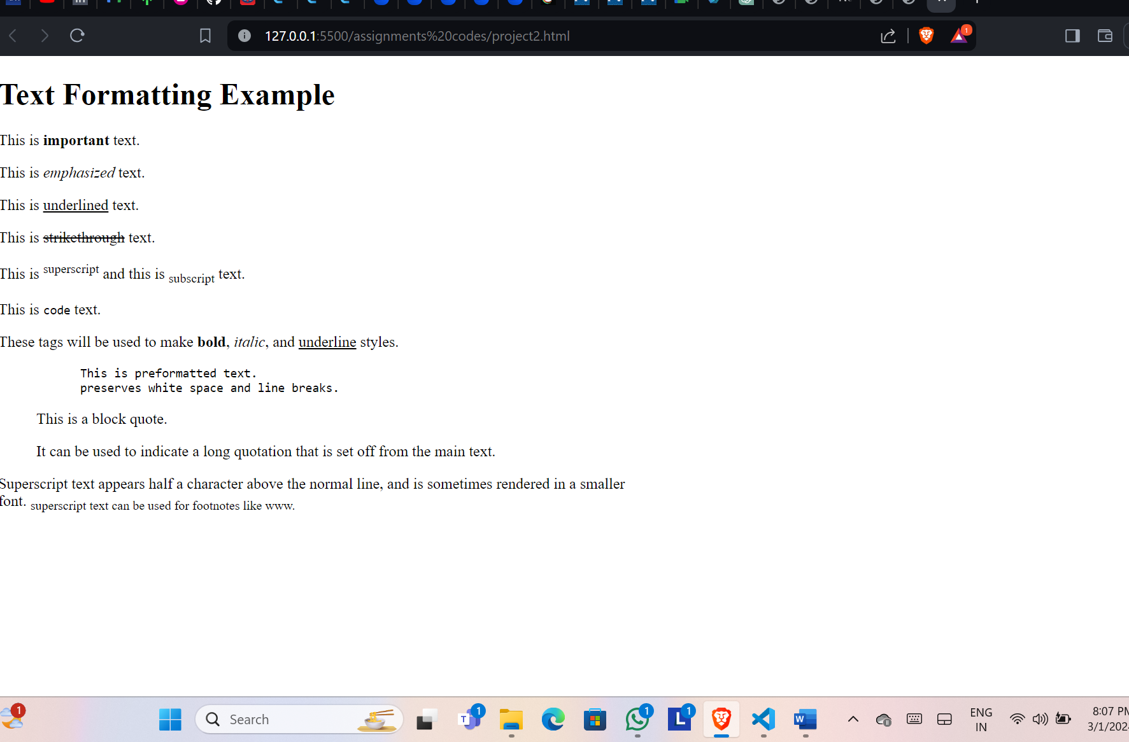

**3.Write a program to show all form input controls in HTML5 as given below ?**

**HTML CODE**:

<!DOCTYPE html>

<head>

<title>Form Input Controls Example</title>

</head>

<body>

<h2>Form Input Controls Example</h2>

<form>

<label for="name">Name:</label>

<input type="text" id="name" name="name" placeholder="Enter your name">

<label for="password">Password:</label>

<input type="password" id="password" name="password" placeholder="Enter your password">

<label for="email">Email:</label><br>

<input type="email" id="email" name="email" placeholder="Enter your email">

<label for="age">Age:</label>

<input type="number" id="age" name="age" value="18">

<label for="rating">Rating:</label>

<input type="range" id="rating" name="rating" min="0" max="10" value="5">

<label for="dob">Date of Birth:</label><br>

<input type="date" id="dob" name="dob" value="2000-01-01">

<label for="time">Time:</label>

<input type="time" id="time" name="time" value="12:00">

<label for="image">Image:</label>

<img src="Screenshot 2024-03-01 204421.png" width="150px" height="50px">

<br><br>

<label for="week">Week:</label>

<input type="week" id="week" name="week"><br><br>

<label for="month">Month:</label>

<input type="month" id="month" name="month"><br><br>

<label for="datetime-local">Datetime-Local:</label>

<input type="datetime-local" id="datetime-local" name="datetime-local"><br><br>

<label for="url">URL:</label>

<input type="url" id="url" name="url" ><br><br>

<label for="search">Search:</label>

<input type="search" id="search" name="search"><br><br>

<br>

<label for="gender">Gender:</label><br>

<input type="radio" id="male" name="gender" value="male">

<label for="male">Male</label>

<input type="radio" id="female" name="gender" value="female">

<label for="female">Female</label><br><br>

<label for="interests">Interests:</label><br>

<br>

<input type="checkbox" id="reading" name="interests" value="reading">

<label for="reading">Reading</label>

<input type="checkbox" id="sports" name="interests" value="sports">

<label for="sports">Sports</label>

<label for="country">Country:</label>

<select id="country" name="country">

<option value="ind">India</option>

<option value="us">United States</option>

<option value="uk">United Kingdom</option>

<option value="ca">Canada</option>

</select>

<label for="message">Message:</label><br>

<textarea id="message" name="message" rows="4" cols="50" placeholder="Enter your message"></textarea>

<input type="submit" value="Submit">

</form>

</body>

</html>

**OUTPUT:**

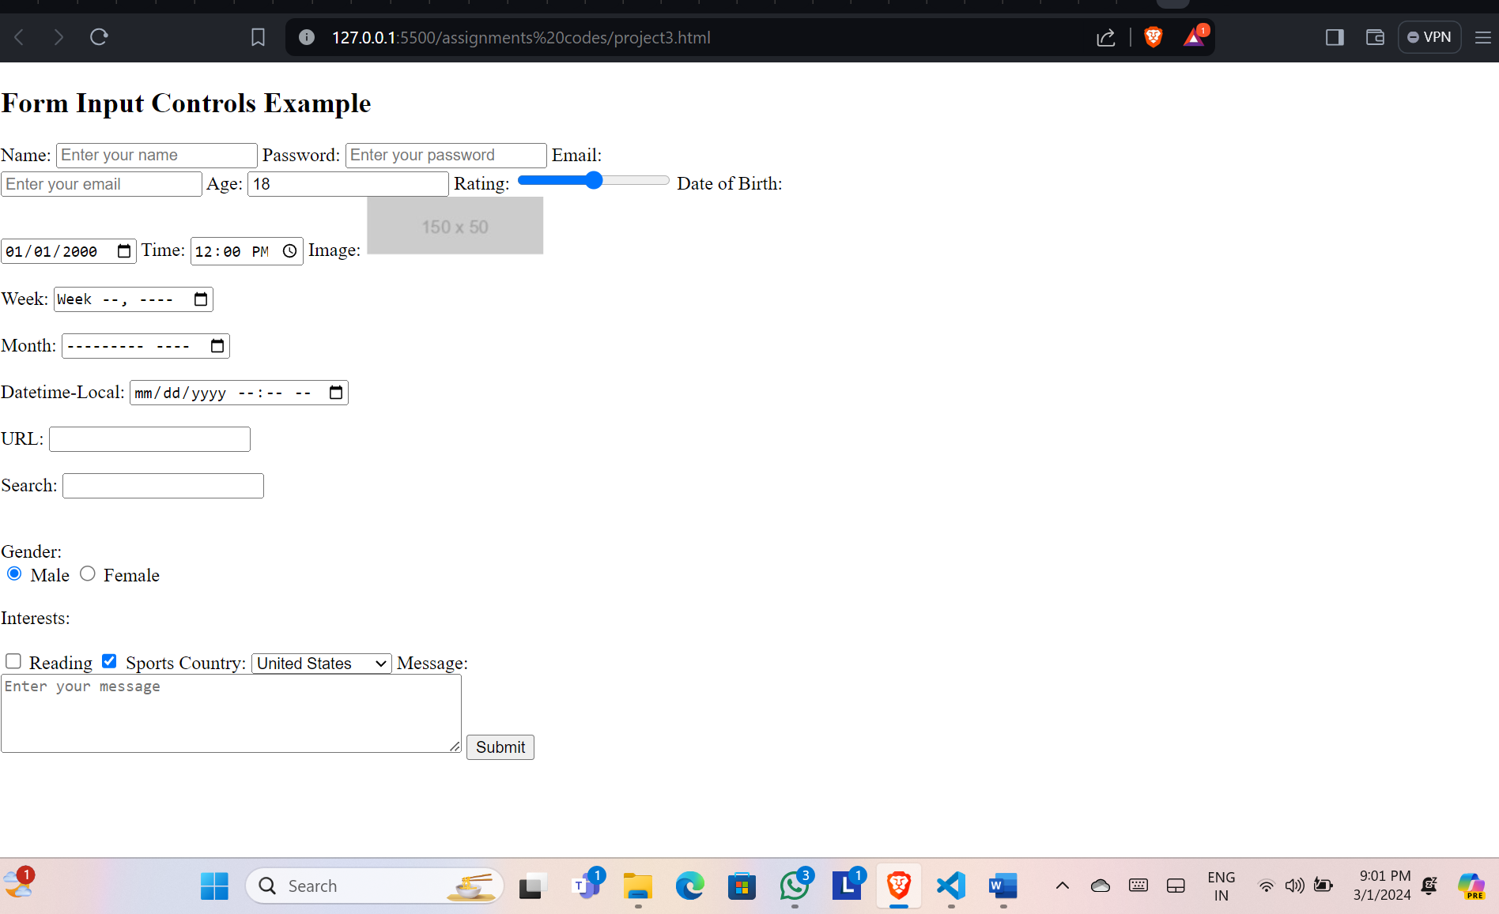

**4.Write a program to load multimedia content into a webpage like given below?**

**HTML CODE**:

<!DOCTYPE html>

<head>

<title>My Multimedia Website</title>

</head>

<body>

<!-- Video -->

<h1>Video</h1>

<video width="320" height="240" controls>

<source src="video.mp4" type="video/mp4">

Your browser does not support the video tag.

</video>

<br><br>

<!-- IFrame -->

<h1>IFrame</h1>

<iframe src="https://www.youtube.com/embed/nhXja-DNeJg?si=z6jX25Umi-EKWqPz" title="YouTube video player" frameborder="0" allow="accelerometer; autoplay; clipboard-write; encrypted-media; gyroscope; picture-in-picture; web-share" allowfullscreen width="600" height="400" ></iframe>

<br><br>

<h1>My Multimedia Website</h1>

<!-- Image -->

<h1>Image</h1>

<img src="Excelrphoto.png" width="600" height="400" alt="EXCELR">

<br><br>

<!-- Audio -->

<h1>Audio</h1>

<audio controls>

<source src="audio.mp3" type="audio/mpeg">

Your browser does not support the audio tag.

</audio>

</body>

</html>

**OUTPUT:**

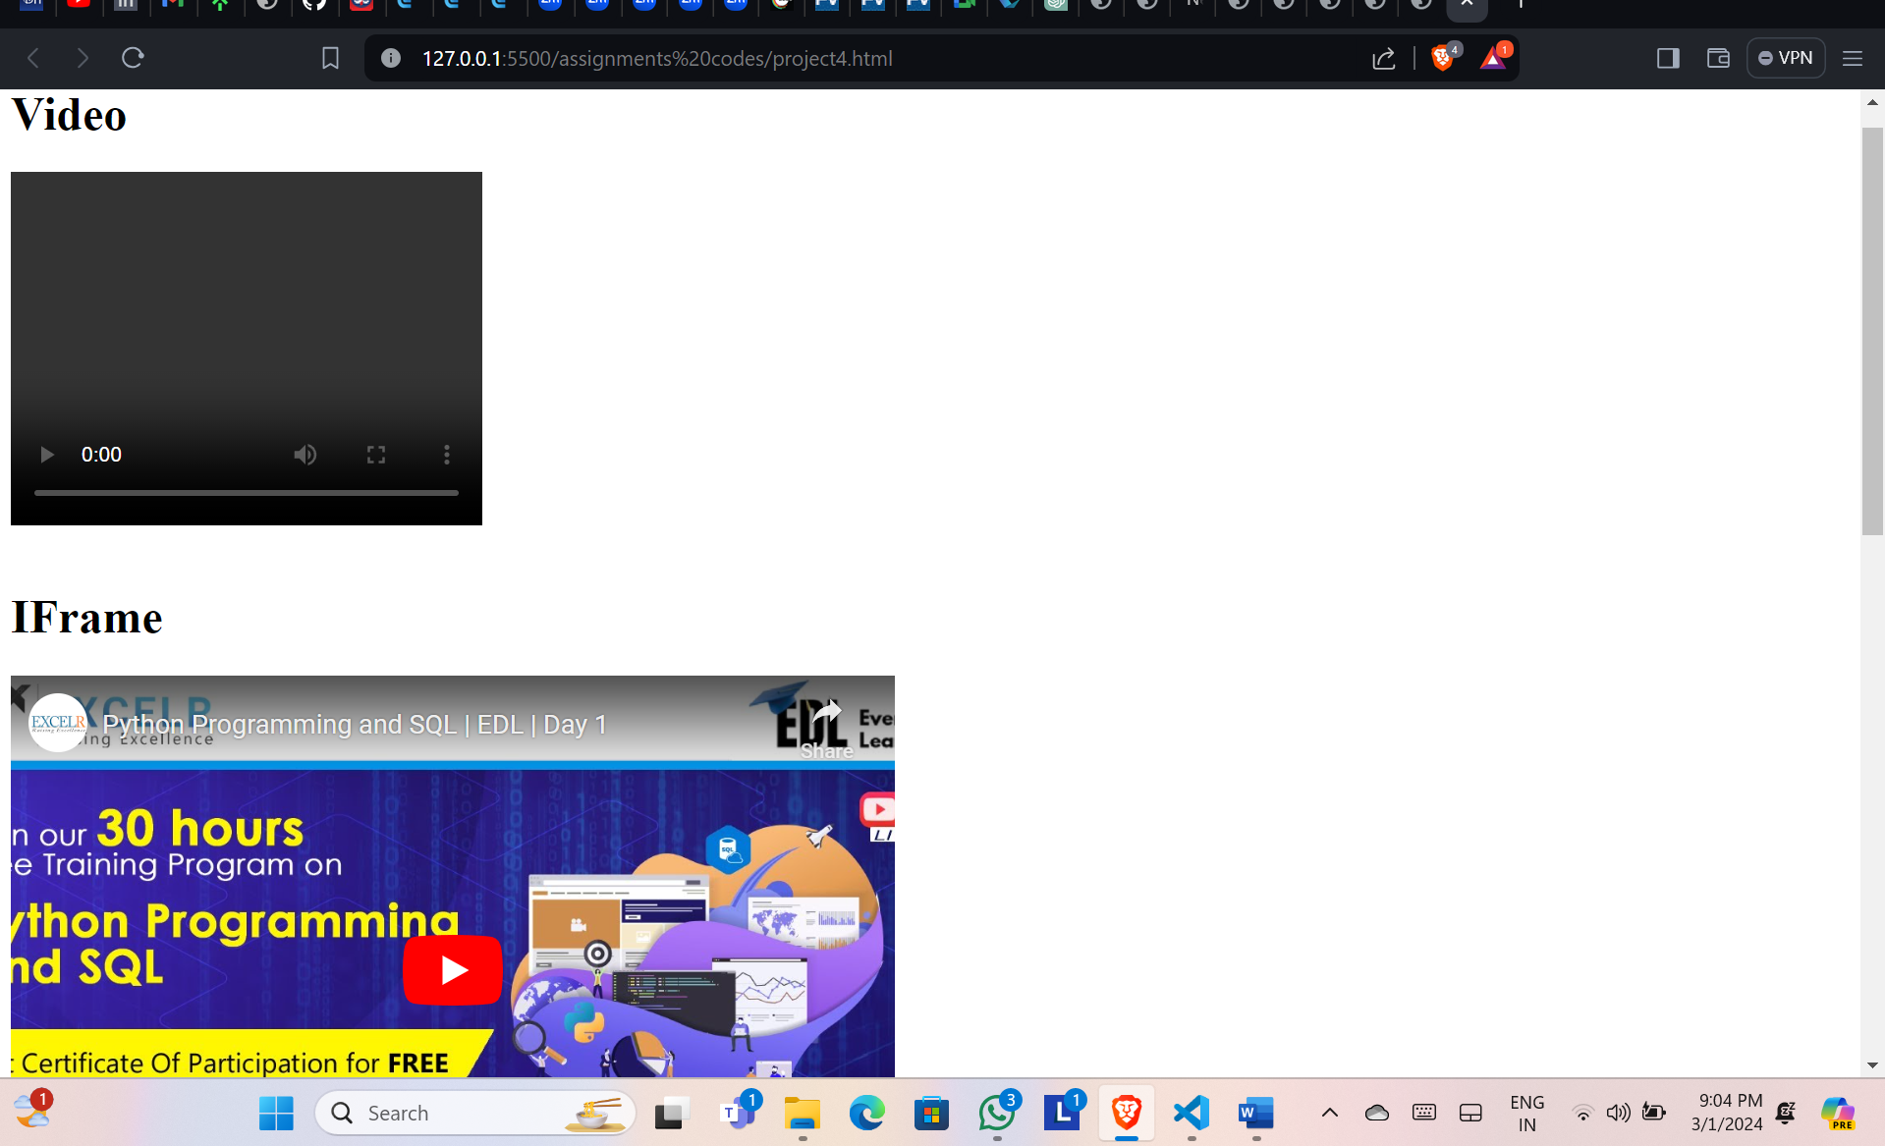

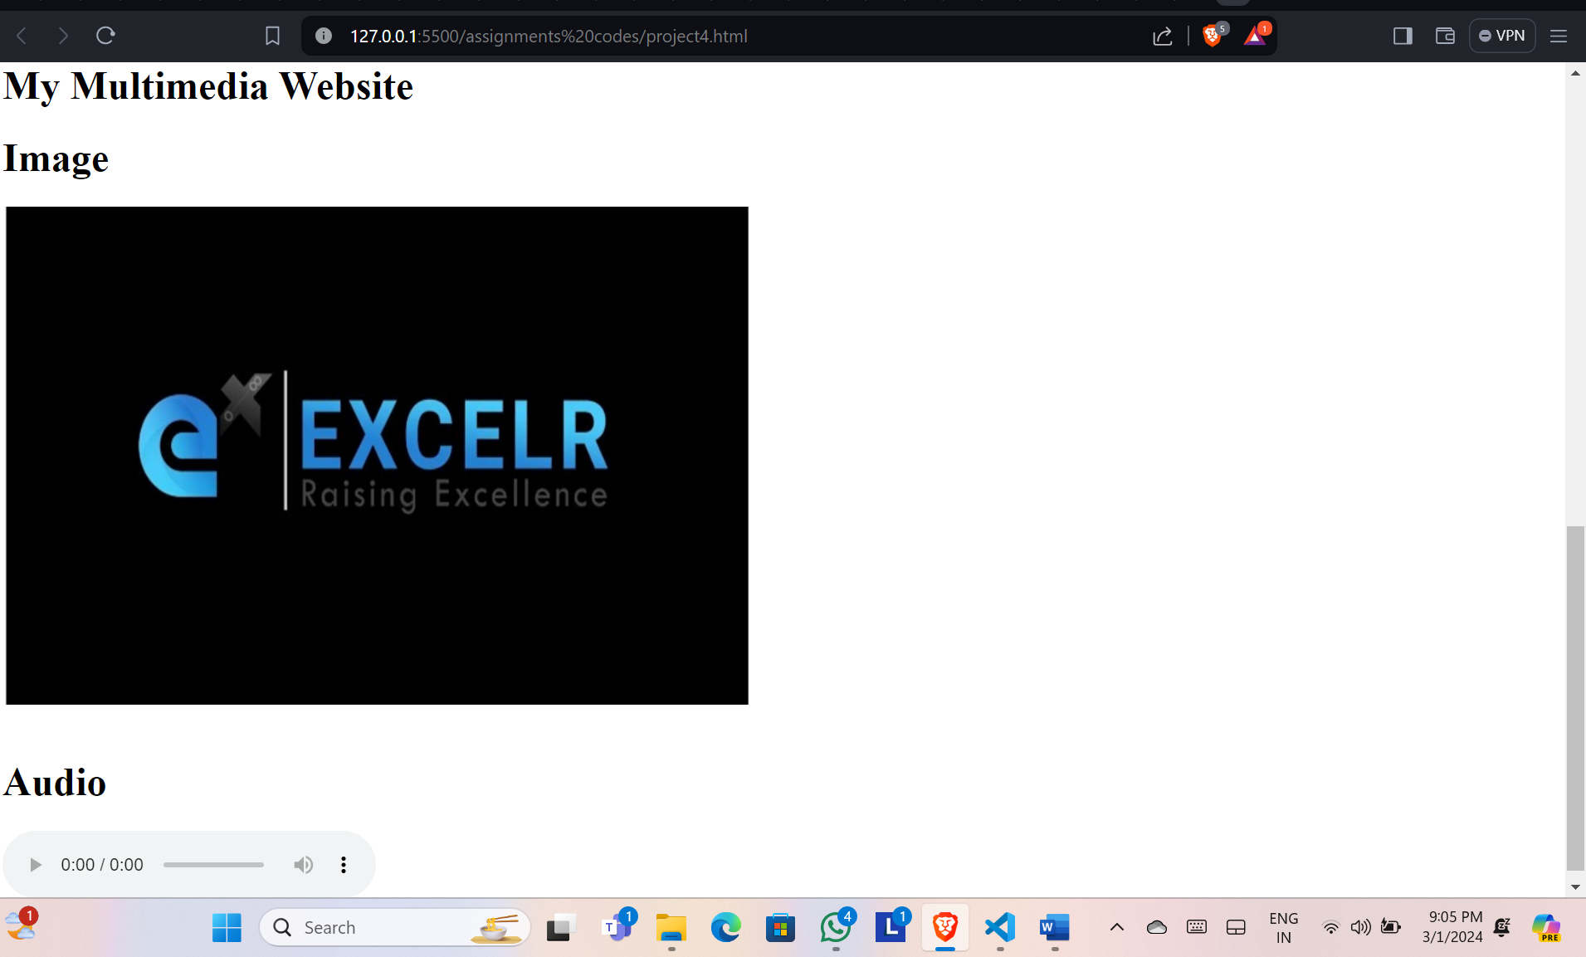

**5.Write a program to create ‘SVG’ inline and external like given below?**

**HTML CODE**:

<!DOCTYPE html>

<head>

<title>SVG Examples</title>

</head>

<body>

<!-- Inline SVG Example -->

<h1>SVG Inline Graph</h1>

<svg width="200" height="200">

<rect x="50" y="50" width="100" height="100" fill="red" />

<circle cx="100" cy="100" r="40" fill="white" />

</svg>

<!-- External SVG Example -->

<h1>External SVG Example</h1>

<!-- external.svg -->

<img src="excelr.svg" width="260px" height="130px" />

<img src="error.svg" width="130px" height="135px" />

</body>

</html>

**OUTPUT:**

